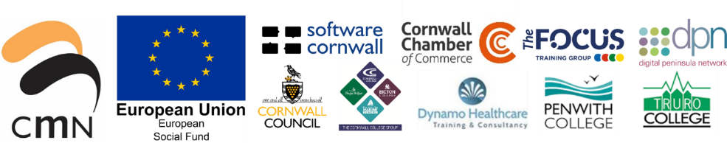

**European Social Fund – Employer Led Skills Project (ELS)**

**Specification Reference: Level 2 Certificate in Spectator Safety**

**ESF Priority Axis:** Priority Axis 2: Skills for Growth

**ESF Investment Priority 2.1:** Enhancing equal access to lifelong learning

**Area:** Cornwall and Isles of Scilly (C&IoS)

**Opens:** 21st February 2022

**Closes:** 4th March 2022

|  |
| --- |
| **Name of Training Provider:** |

|  |  |  |
| --- | --- | --- |
| *Before you complete this template use the bullets below to check that your organisation is able to offer all of the required elements:*   * *Level 2 Certificate in Spectator Safety qualification (RQF)* * *Basic Life Support qualification* * *a programme of face-to-face courses in the West of Cornwall, in March 2022, for up to 150 participants*   *If you believe your organisation can deliver all of the above please continue to complete the template.*  *You are welcome to include additional documents as supporting evidence for any of the points in the template below.* | | |
| **Experience & Skills** | **YES/NO** | **Evidence (copies of certificates included with submission/comment to evidence YES or NO response)** |
| Qualified to the appropriate specialist level and able to confidently deliver and assess the qualifications requested |  |  |
| Capacity to deliver the programme within the timescale, and at the volume, required  (commencing March ’22, West Cornwall, up to 150 participants) |  |  |
| Offer good value for money |  |  |
| Hold appropriate levels of insurance (professional, indemnity, public liability) |  |  |
| Have demonstrable experience of delivering high quality training packages |  |  |
| Have up to date training on safeguarding and PREVENT |  |  |
| hold a recent and relevant DBS, or apply for a DBS check and provide a copy to CMN |  |  |

|  |  |  |  |
| --- | --- | --- | --- |
| **About your training offer** *(add more rows as required)* | | | |
| **Qualification** | **Awarding Body**  **(if applicable)** | **Duration** | **Cost** |
| Lv 2 Certificate in Spectator Safety |  |  |  |
| Basic Life Support |  |  |  |
| Any other qualifications felt relevant (value added) |  |  |  |
|  |  |  |  |

|  |
| --- |
| **Cross cutting themes** |
| **Gender equality & equal opportunities** |
| *Use this space to explain how these areas of E&D are embedded within the delivery of your training offer. Please provide some examples.* |
| **Sustainable development** |
| *Use this space to explain how the theme of sustainable development is embedded within the delivery of your training offer. Please provide some examples.* |

**Signature on behalf of Training provider:**

**Date:**

Please return to [**anne-marie.sefton@cornwallmarine.net**](mailto:anne-marie.sefton@cornwallmarine.net)or by post to Anne-Marie Sefton, Projects & Training Coordination Manager, Cornwall Marine Network, Maritime Business Centre, Units 7a & 7b Falmouth Business Park, Bickland Water Road, Falmouth, TR11 4SZ